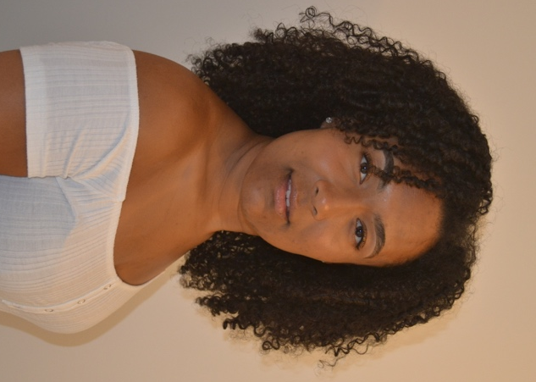
Beatrice John
Mobile: 07598 255447
Email: Beatrice.john@sky.com
Location: South East England
Playing Age: 16-26
Height: 5’8 Build: Slim Hair: Black Eyes: Brown
Ethnicity: Mixed race
Accents: RP, London/South East
Training:
2017-2020 Southampton Solent University: BA (Hons) Acting and Performance

Theatre and Screen Credits:
Theatre
2020 | Play | Miss P | Tea | Nuffield Southampton Theatre (NST) | Oliver Bruce
2019 | Play | Doctor Rock | The Doctor and the Devils | Solent University | Matt Fletcher
2019 | Play | Ensemble/vocal captain | The Shadow Factory | Nuffield Southampton Theatre (NST) | Sam Hodges
2018 | Music Theatre Play | Stapleton | Sherlock Holmes and the Hound of the Baskervilles | Solent University | Annie Sanger-Davies
2018 | Play | Paige | ‘I Told My Mum I Was Going on an R.E Trip…’ | Solent University | Maddie Wilcox
2018 | Play | Hotel Manager | The Night Shift | Solent University | Matt Fletcher
2018 | Play | Ensemble | The Shadow Factory | Nuffield Southampton Theatre (NST) | Sam Hodges

Film and Television
2020 | Short Scene | Angelica White | Know Your Enemy | Solent | Lauren Butler
2019 | Short Film | Zelda | Rise | Solent | Keith Kopp
2019 | Short Scene | Alex | Suppressive Person | Solent | Millie Everett
2018 | Short Scene | Jacques | As You Like It | Nuffield Southampton Theatre (NST) | Oliver Bruce
Skills: (*= highly skilled) Full driving license, Hockey*, Skiing*, Swimming, Diving, Synchronise Swimming, Cycling, Horse Riding
Musical Skills:
Singing Grade 8 – Alto, chorus and solo singing
Instruments - Cello Grade 5 and basic piano

